Academic Research Databases
From the Lamar Writing Lab (www.tinyurl.com/LamarWritingLab)
Table of Contents:
Houston Public Library
HPL A-Z Databases
Gale Academic Onefile
Gale Academic Onefile: Topic Search
ProQuest
ProQuest Search Tips
HPL Digital Catalog (eBooks!)

Houston Public Library 
You have access to these resources through the Houston Public Library:
Log into the HPL at this link. *Bookmark it on your computer!*
USER NAME: First letter of last name + student ID number
PIN: MMDD (date of birth)
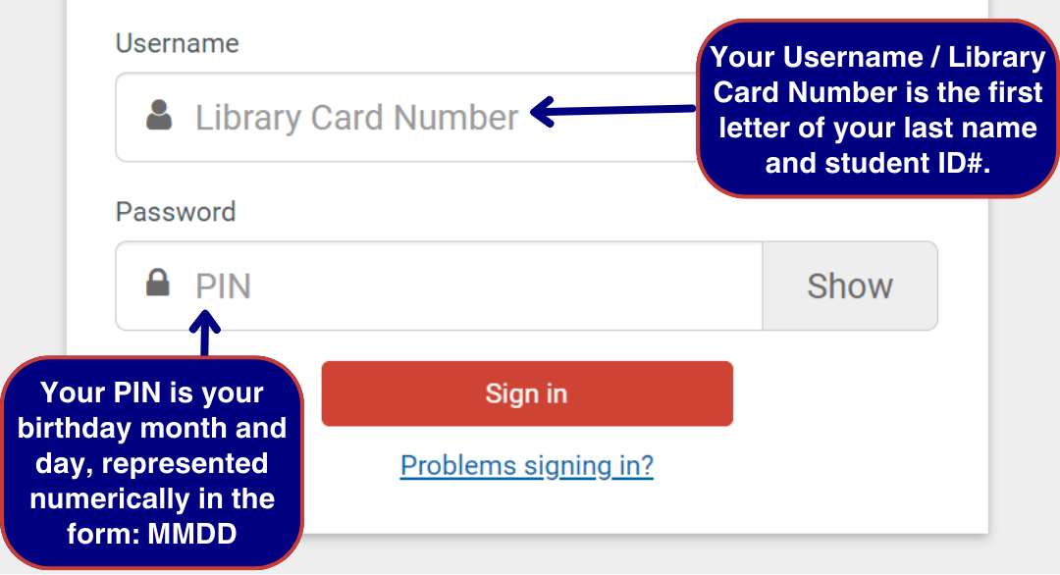
We also recommend you choose “Save Password” in your browser for next time!

HPL A-Z Databases

- Under the “Research” tab at the top of the page, find A-Z Databases.
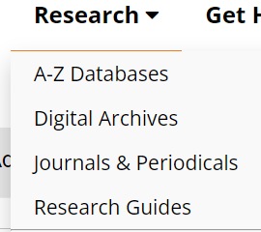
- Browse and see what will be useful for your research! We recommend Gale Academic Onefile (see instructions below), but there are many very specific databases that you may find useful to your research!
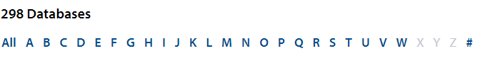

Gale Academic Onefile | 
Find under “G” in the HPL A-Z Databases. https://houstonlibrary.org/az.php

Multiple browsing options by discipline:
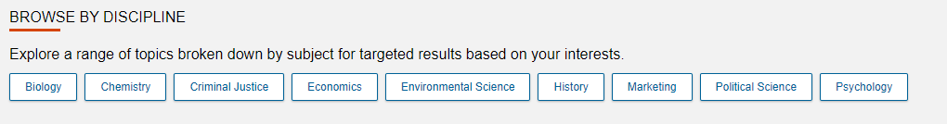
Additional Search Tool Options: Topic Finder, Subject Guide Search, and Publication Search:
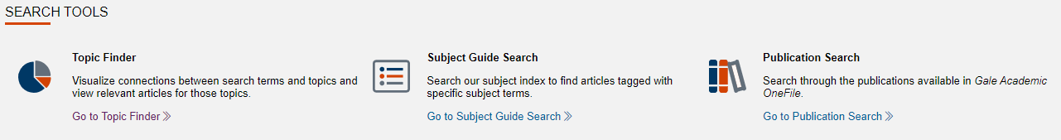

Never lose an article or piece of research when you do these two things:
- When you pull up a source, DOWNLOAD the PDF to your computer to upload it to a folder in your Google Drive so you can easily access it later without having to go through the database again.
- Create a list of your sources by the CITATION information (Author! Title! Date! Publisher! Link!) on a Doc. Most academic databases will generate a citation for you that you can just copy + paste.
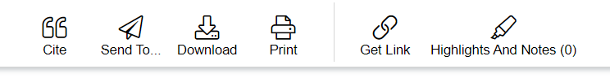

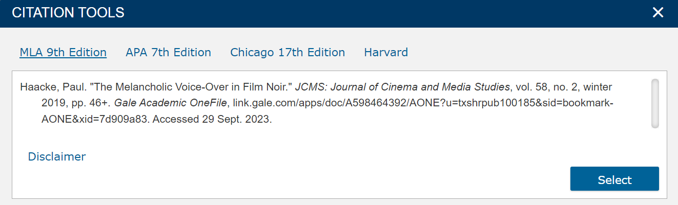

Gale Academic Onefile: Topic Search
HOW IT WORKS:
This tool takes the titles, subjects, and approximately the first 100 words from a subset of your top results and feeds them into an algorithm. Keywords shown in the graphics are those found most often in the text with your search term.
The topic for “Illinois” might bring up expected connections from the text like “Chicago,” along with unexpected but commonly related terms like “water,” “steel,” and the names of people who appear frequently in documents about Illinois.  For example, if I search “ACL injury,” this is how all the research is pulled up… | 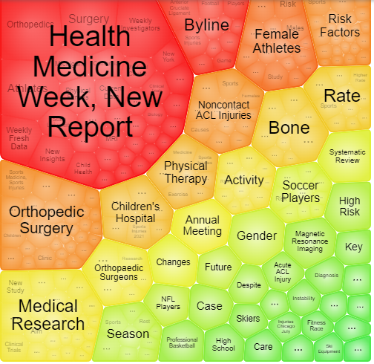
I can then click through each cluster and find related articles under that search!  And I’ll make sure to download each source that I find useful and save them in a Google Drive folder of my research so that I can easily find them again! | 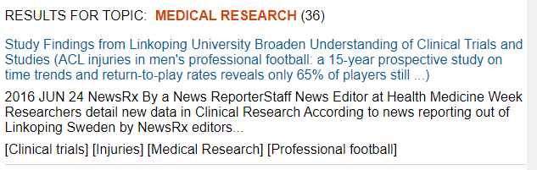

ProQuest | 
- Access ProQuest directly at ProQuest.com!
- Click Log in through your library at the top of the page:

- Choose Open Athens:
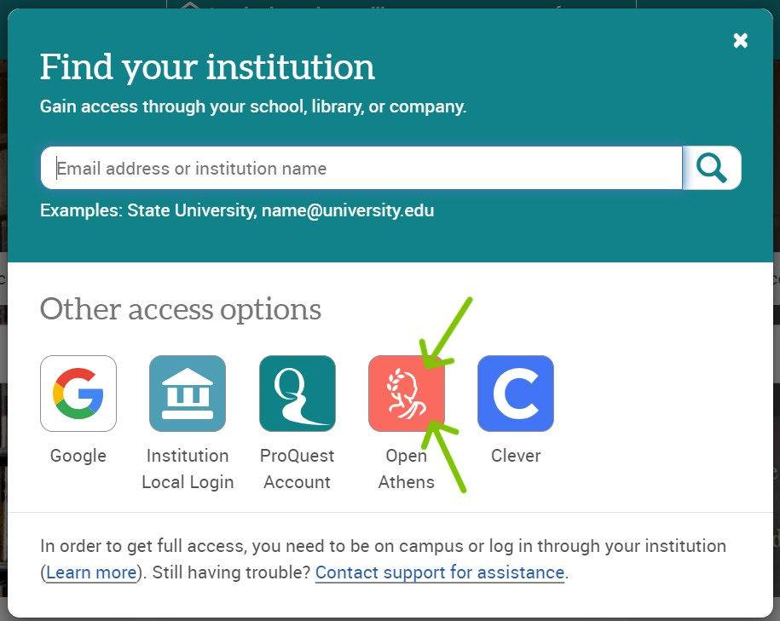

- Search “Houston Public Library” and choose it from the drop-down menu:
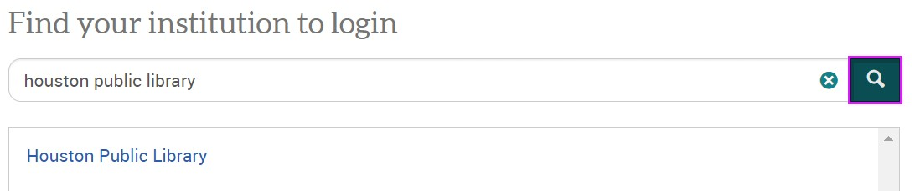

- Use your same login to sign in with your Houston Public Library account:

When you’re signed in, you’ll see “Access provided by Houston Public Library” at the top of the page:


ProQuest Search Tips
Never lose an article or piece of research when you do these two things:
- When you pull up a source, DOWNLOAD the PDF to your computer to upload it to a folder in your Google Drive.
- Create a list of your sources by the CITATION information (Author! Title! Date! Publisher! Link!) on a Doc. Most academic databases will generate a citation for you that you can just copy + paste.

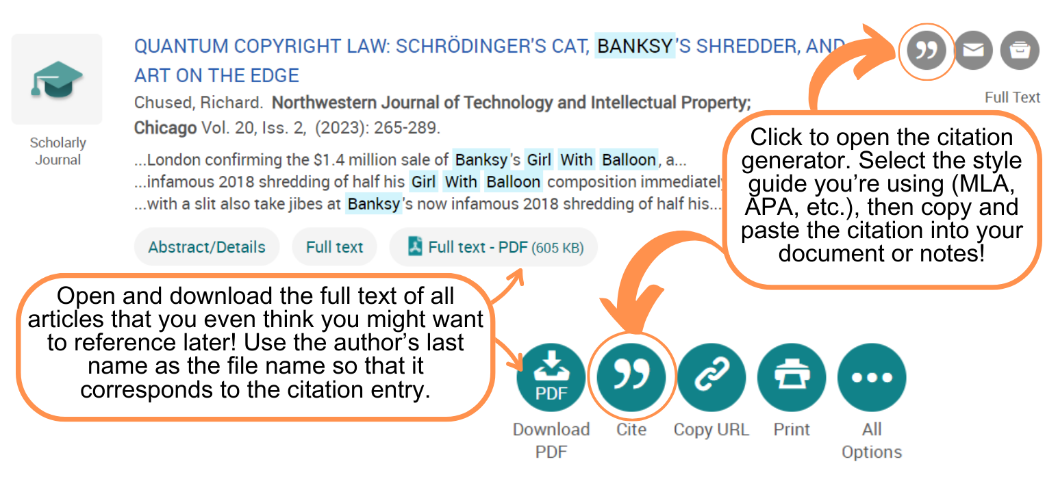

When you enter search terms on the Basic Search page, you can choose the types of sources you want ProQuest to pull up.
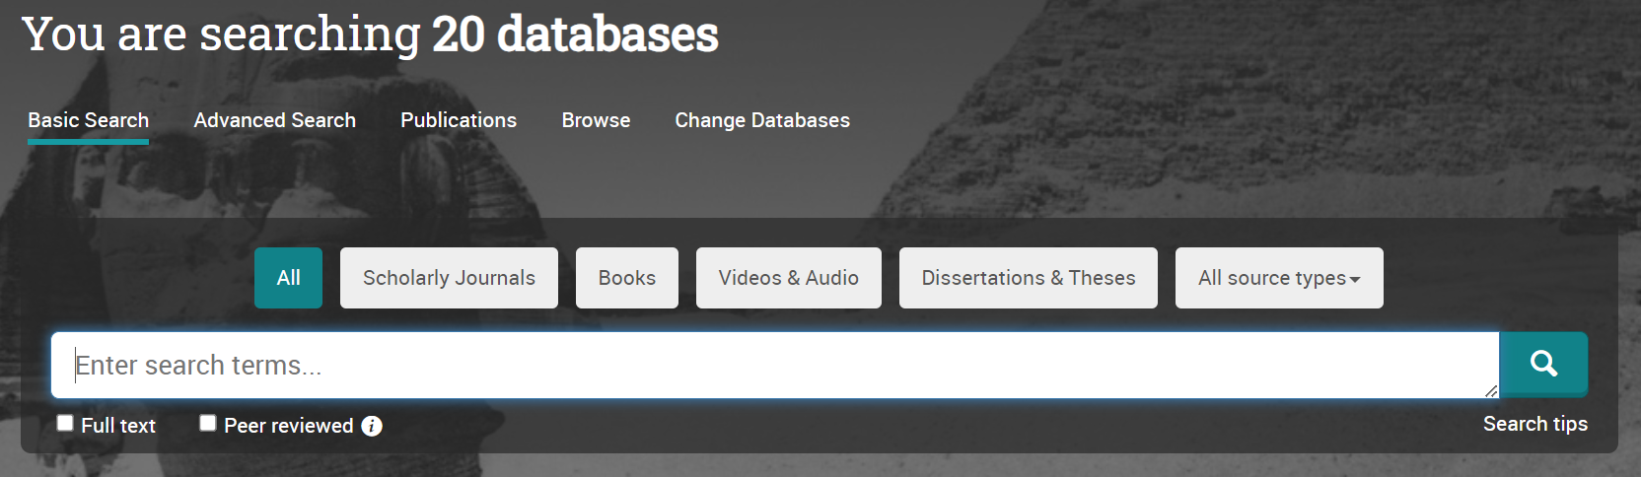

Typically if your teacher has asked you to use “academic” or “peer-reviewed” sources, they mean Scholarly Journals. Start there!


You can also get a little more detailed in the Advanced Search page!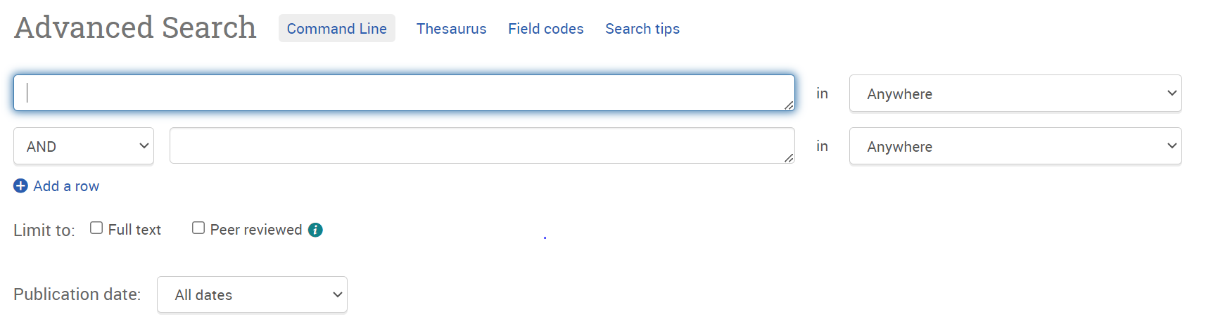
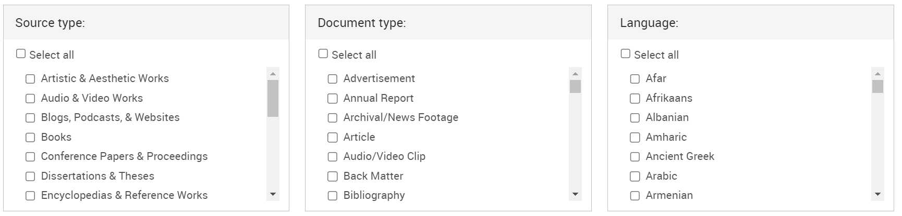

HPL Digital Catalog (eBooks!)
- When logged in to your account, you can access the entire HPL electronic catalog for ebooks and audiobooks under “Browse & Borrow” by clicking “Catalog.”
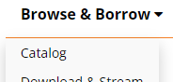
- Narrow your catalog search to ebooks by choosing “eBooks” under “Format” once you’ve typed in your search terms.  You can also access audiobooks, electronic resources, and music recordings!! | 